|  |  |
| --- | --- |
| W:\OSMS Inc\Logo and printer files\OSP LOGO\OSP Final Logo.jpg | Online payment for  Before and After School fees  Credit and Debit cards accepted |

* Are you tired of making an extra trip to school to pay a fee?\*
* Are you tired of sending you kids to school with cash or checks that they misplace?
* Would you rather make a payment anytime from the comfort of your own home?

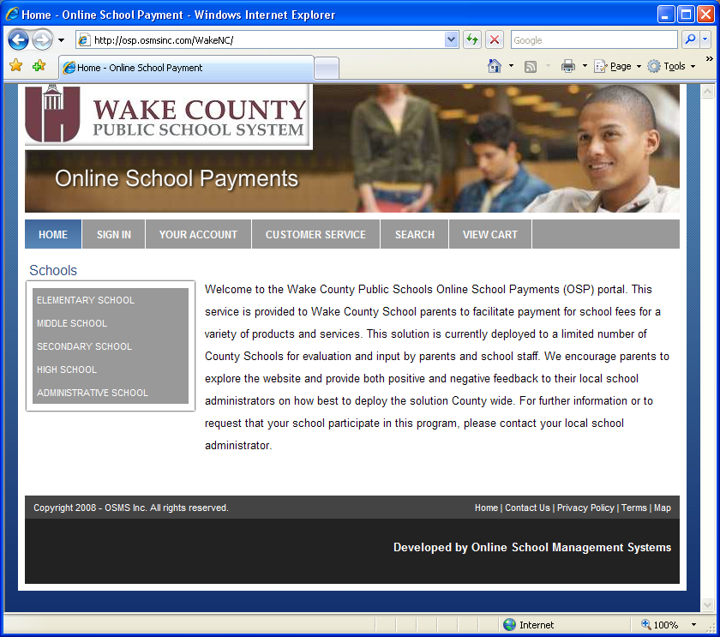If you answered yes to any of these questions, please visit our new payment site where you can now pay your student’s before and after school fees by debit or credit card online using a web browser from any location, 24 hours a day.

**C:\Documents and Settings\judy_williams\Local Settings\Temporary Internet Files\Content.IE5\K6BR4L2Q\MC900442036[1].wmf**

**\*Registration for childcare programs must take place at school. Registration fees are paid at the time of enrollment at school. You cannot enroll your child in the program using OSP. Once you have enrolled your child, use OSP to make your regular childcare payments.**

http://osp.osmsinc.com/wakencW:\OSMS Inc\Logo and printer files\credit_card_logos_10.gif